## Value functions and Backup diagrams

It is given that,

S = { s0 , s1 }

A = { a0 , a1 , a2 }

## 

### Part 1

1. Draw a backup diagram starting from state s0. (one level)

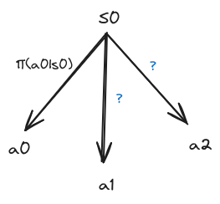

1. How valuable it is to start from state S0 using the backup diagram drawn in question1.

vπ(s0) = π(a0 | s0) * qπ(a0 , s0) + ? + ?

1. Write the expression for state values function vπ(s) in terms of action value function qπ(s, a).

vπ(s) = ?

1. Backup diagram starting from state s0  and taking action a0. (one level)

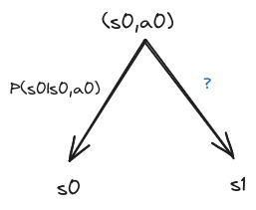

1. How valuable it is to start from state s0 and take an action a0 from the backup diagram above.

qπ(s0, a0) = ? + ?

1. Write the expression of action value function qπ(s, a) in terms of state value function vπ(s).

qπ(s,a) = ?

### Part 2

1. Draw a backup diagram starting from state s0. (two level)

### 

1. How valuable it is to start from state S0 using the backup diagram drawn in question 7.

vπ(s0) = π(a0 | s0) * [ P(s0|s0, a0) * ? + P(s1|s0, a0) * ? ] + ? + ?

1. Write the general form of expression for state values function vπ(s) by using the equation from the previous question. Hint: Use summations.

vπ(s) = ?

1. Backup diagram starting from state s0  and taking action a0. (two level)

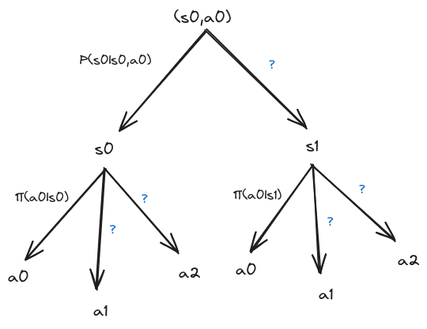

1. How valuable it is to start from state s0 and take an action a0 using the backup diagram from the above question.

qπ(s0, a0) = ? + ?

1. Using the equation obtained in the previous question, write the general form of expression of action value function qπ(s, a).

qπ(s,a) = ?